Where to go :
After Python

Resources and Recommendations
- For creating GUIs in python : https://tkinter.com/
Tkinter is the standard Python GUI (graphical user interface) library, providing a fast, cross-platform way to create desktop applications.

- For ML go to YouTube : https://www.youtube.com/results?search_query=machine+learning+recipes+with+josh

Books :
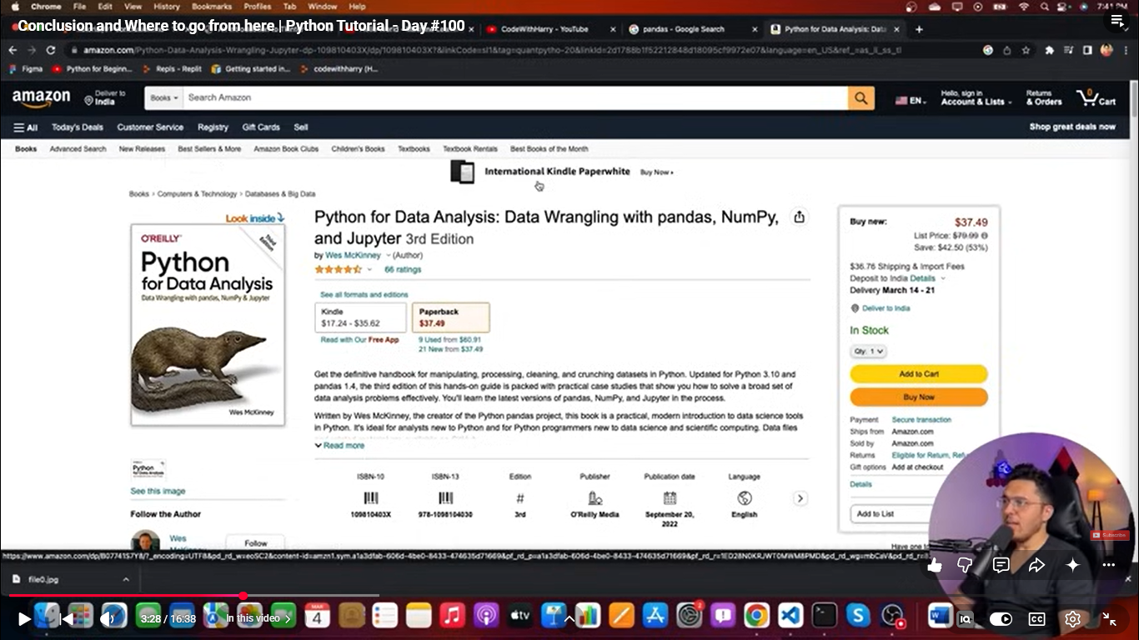
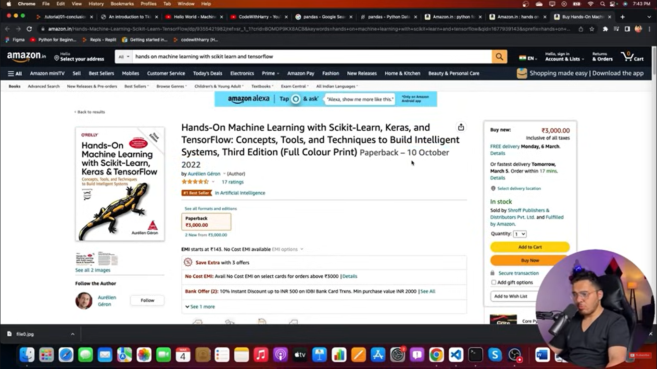
Tensorflow hub : https://www.tensorflow.org/hub

Libraries for ML :
- Pandas
- Numpy
- Tensorflow
- Pytorch
- Scikit Learn
- Matplotlib

